* Someone at a restaurant chain with responsibility for deciding which wines get included on the national wine list and the prominence of their placement. (I’ll do catering for multiple arena suites across the country example)

Step 1. Business Understanding (Your reading and additional investigation is meant to achieve this step).

|  |  |  |
| --- | --- | --- |
| **Name** | **Type** | **How calculated/derived** |
| Wines sold at other arenas | Descriptive | Summarized from multiple arena websites suite menu list |
| Sales categorized by type of event | Descriptive | Summarized by POS transactions |
| Sales categorized by seasons | Descriptive | Summarized by POS transactions |
| Wine List Design | Descriptive | Based on numerous tips from experts see Appendix A (Snarky Guys) |
| Pairing of Wine and Food | Descriptive | Food and wine see Appendix A |
| Pricing of each wine | Descriptive | Summarized from multiple arena websites suite menu list |
| Wine sales during pandemic | Predictive | Multiple websites see Appendix A (Forbes 1) |
| Analysis of wine sales during pandemic & steps to take build revenue back into wine sales | Prescriptive | Multiple websites see Appendix A (Forbes 2) |
| Loyalty & customers & customers willing to pay more and try diff wines out | Descriptive | Multiple Websites see Appendix A (Lohud 1) |
| Effective wine marketing tactics | Predictive/Prescriptive | Appendix A (sfgate 1) |
| Marketing strategies | Prescriptive | Appendix A (buzztime 1) |

Spokane arena: <http://www.spokanearena.com/documents/catering-menus.pdf>

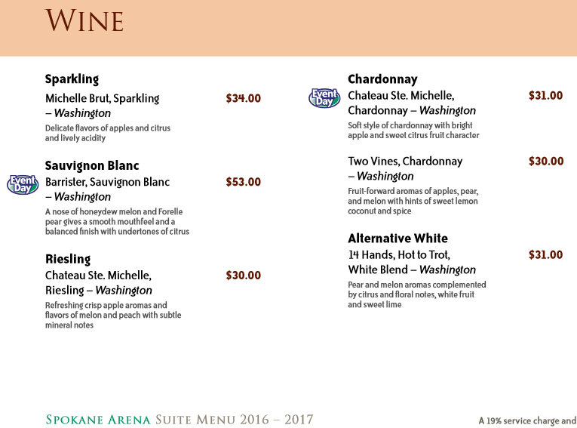

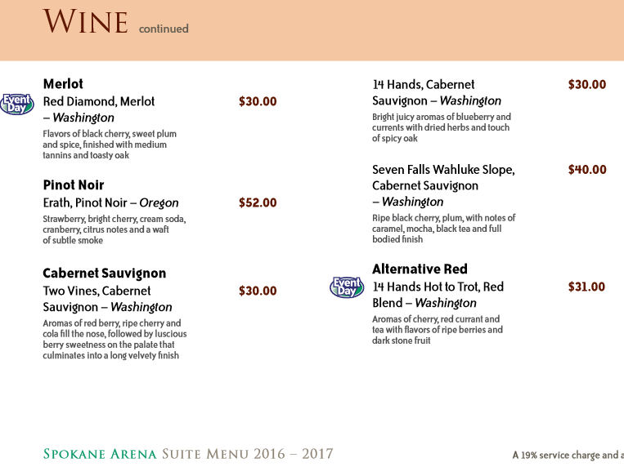

Spokane arena researches seattle’s pricing and the gorge for beer and wine pricing.

PNC Arena Indoor arena in Raleigh, North Carolina

<https://www.pncarena.com/assets/doc/16-17_SuiteMenu_v6-50b4bbdf47.pdf> 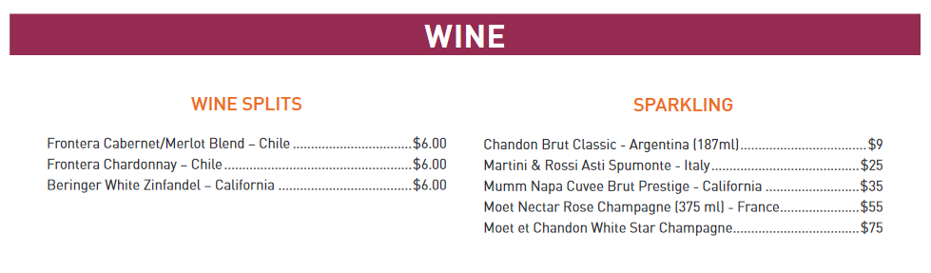

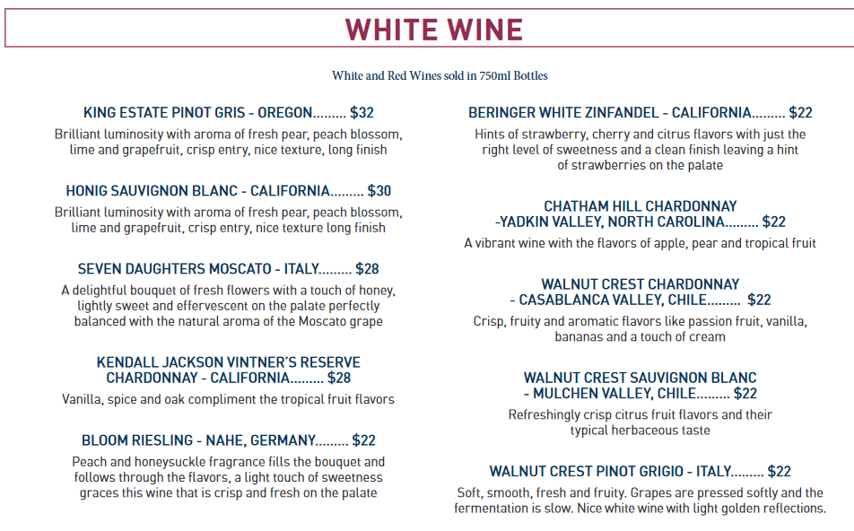

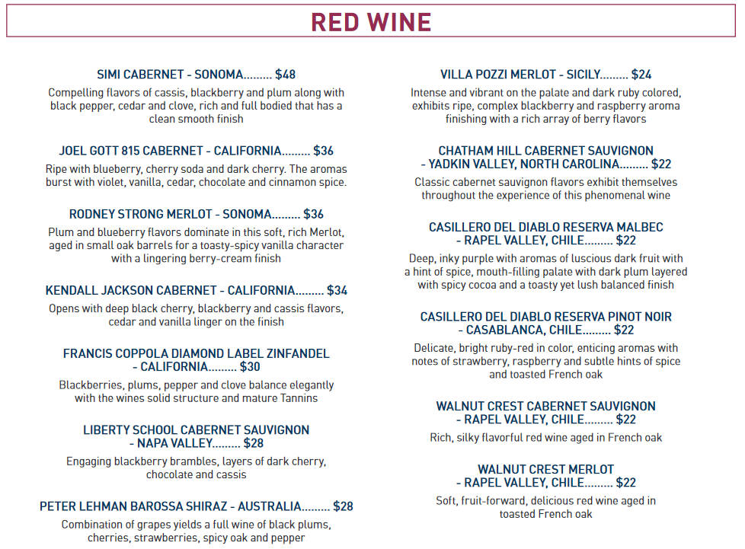

<http://capitalonearenasuites.com/wp-content/uploads/2017/11/COA-Suite-Menu.pdf>

Indoor arena in Washington, D.C.

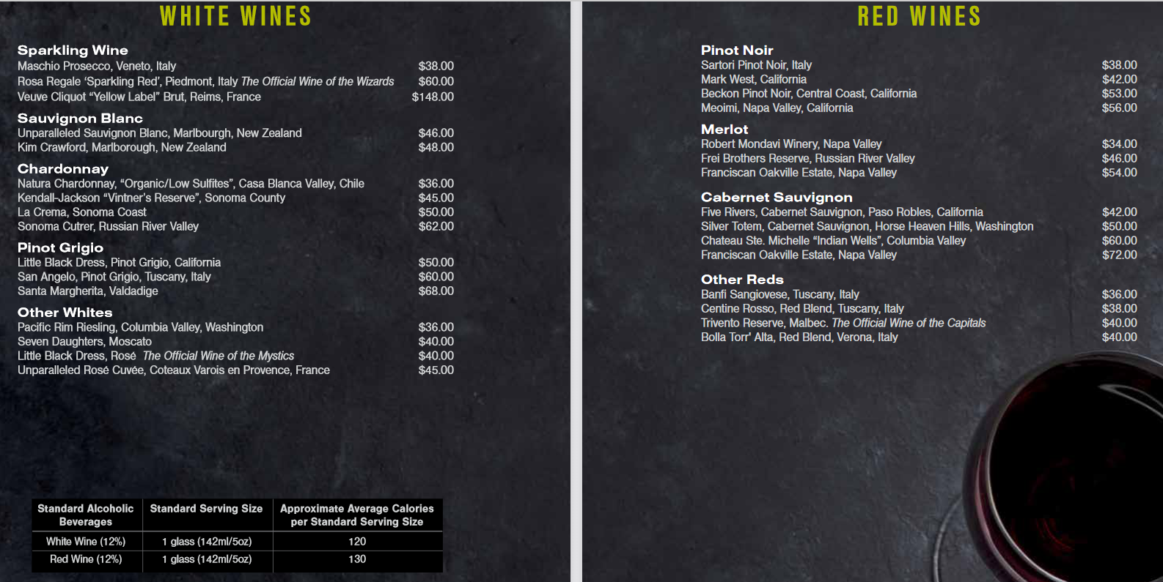

<https://www.forbes.com/sites/lizazimmerman/2020/05/13/major-wholesalers-take-on-the-current-wine-sales-picture/?sh=724f147a67f5> <- Forbes 1

<https://www.forbes.com/sites/lizazimmerman/2020/05/26/a-post-covid-map-to-the-wine-business/?sh=2ad640e66368> <- Forbes 2

<https://www.lohud.com/story/life/food/restaurants/2020/11/24/holiday-wine-sales-ny-nj-store-owners-2020/3743267001/> <- Lohud 1

<https://marketing.sfgate.com/blog/15-of-the-most-effective-wine-marketing-tactics> <- sfgate 1

<https://www.buzztime.com/business/blog/13-trending-bar-marketing-strategies-increase-sales-asap/> <- buzztime 1

<https://www.guildsomm.com/public_content/features/articles/b/back_and_forth/posts/back-and-forth-two-snarky-white-guys-tell-you-how-to-write-your-wine-list> <- snarky guys

<https://www.foodandwine.com/wine/15-rules-great-wine-and-food-pairings?slide=57a32f76-170d-46be-a86b-d0bd1e052016#57a32f76-170d-46be-a86b-d0bd1e052016> <- wine and food

Step 2. Data Understanding (The identification of analytics)

*Armed with the analytics you identified, describe your decision-making process including negotiations with other stakeholders (suppliers, distributors, …)

*Describe how you would measure the success of your decisions and possibly how such measurements should inform future decisions

HW#5 Rubric:

20 points possible

* 5 points – Business Understanding
  + Evidence the provided material was read and understood.
  + Additional investigation as appropriate (there should be some)
  + CRISP-DM Step 1—Business Understanding achieved
* 5 points – Identified Analytics
  + Sufficient to support the decision-making process
  + Demonstrates non-trivial analysis
  + CRISP-DM Step 2—Data Understanding demonstrated
* 5 points – Decision-Making and Measuring Success
  + Decision-making process described and makes sense
  + Mention of specific analytics used in decision-making
  + Techniques for measuring success identified
* 5 points – Professionalism
  + Sources are properly cited
  + Well-formed paper (intro, details, conclusion)
  + Proofread
  + Instructions followed